**DAILY ONLINE ACTIVITIES SUMMARY**

|  |  |  |  |  |  |  |  |  |
| --- | --- | --- | --- | --- | --- | --- | --- | --- |
| **Date:** | **06/0542020** | | | | | **Name:** | **PRANEETA P HANDRAL** | |
| **Sem & Sec** | **4thSEM. & ‘B’ SEC.** | | | | | **USN:** | **4AL19CS401** | |
| **Online Test Summary** | | | | | | | | |
| **Subject** | | **DATA COMMUNICATION** | | | | | | |
| **Max. Marks** | | **30** | | **Score** | | | **25** | |
| **Certification Course Summary** | | | | | | | | |
| **Course** | **Java Programming** | | | | | | | |
| **Certificate Provider** | | | **Greatlearning Academy** | | **Duration** | | | **3.5 Hrs.** |
| **Coding Challenges** | | | | | | | | |
| **Problem Statement:** **Write a program in C to rotate an array by N positions.** | | | | | | | | |
| **Status: Executed.** | | | | | | | | |
| **Uploaded the report in Github** | | | | | **Yes** | | | |
| **If yes Repository name** | | | | | **LockdownCoding** | | | |
| **Uploaded the report in slack** | | | | | **Yes** | | | |

**Online Test Summary:** **18CS46 test was scheduled from 9:15 am to 10:00am. The portion for the IA was 5th module there were 30 questions and the time assigned was 45 minutes the questions were mcq type. There were 30 questions of 1 marks respectively.**

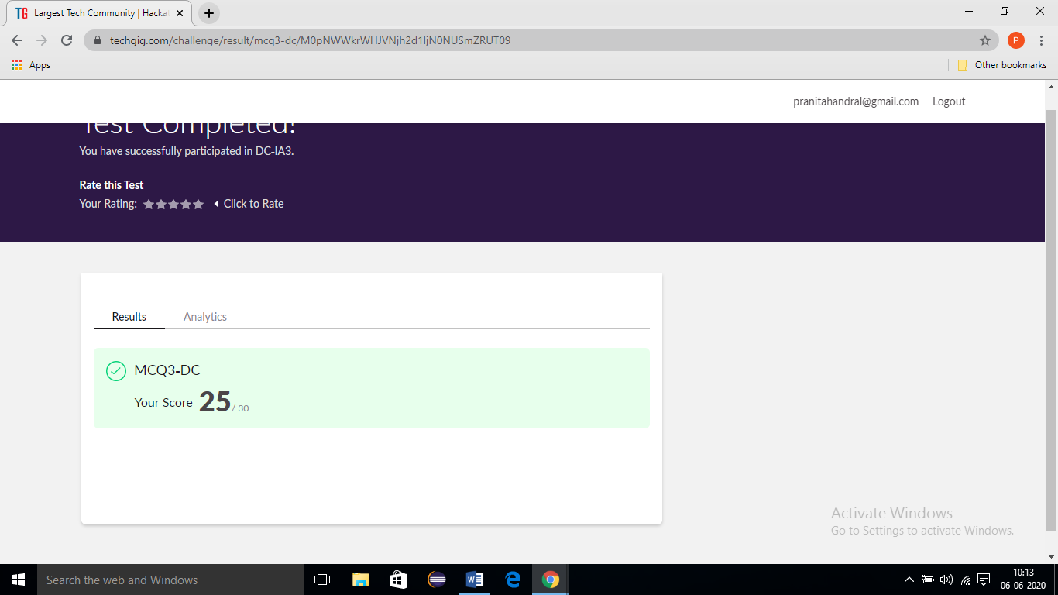

**Online Certification Course Summary:** Today I have learnt about and Operation in java, Flow control statements in java, Array, Function, object oriented programing, inheritance and execute the code and to achieve the output and some of the basic programs. And also today I am attended the test for completion of course and also I score 8 marks in the test finally today I am complete the **Java Programming** certification course I received certification for **Grate learning academy** and I put snapshot of the certificate below:

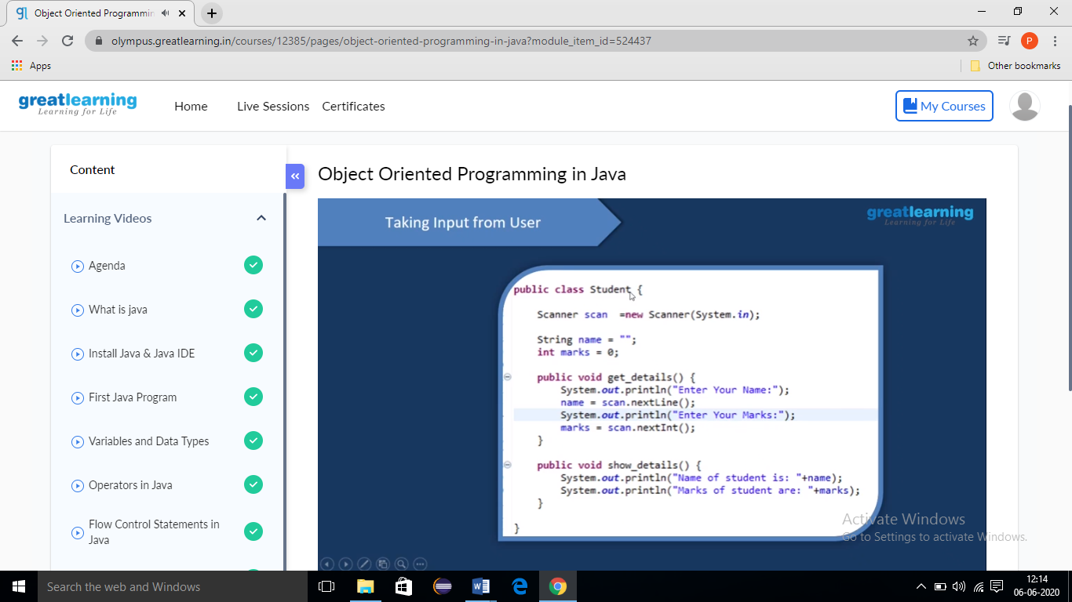

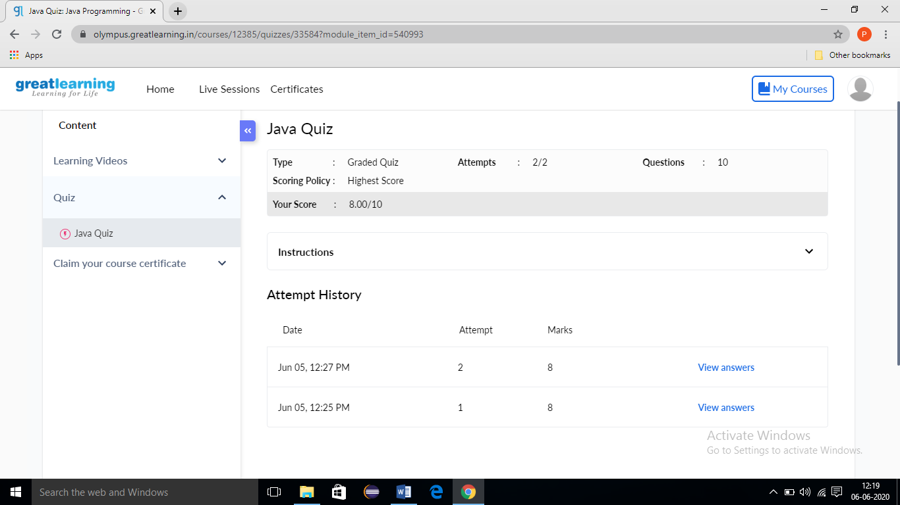

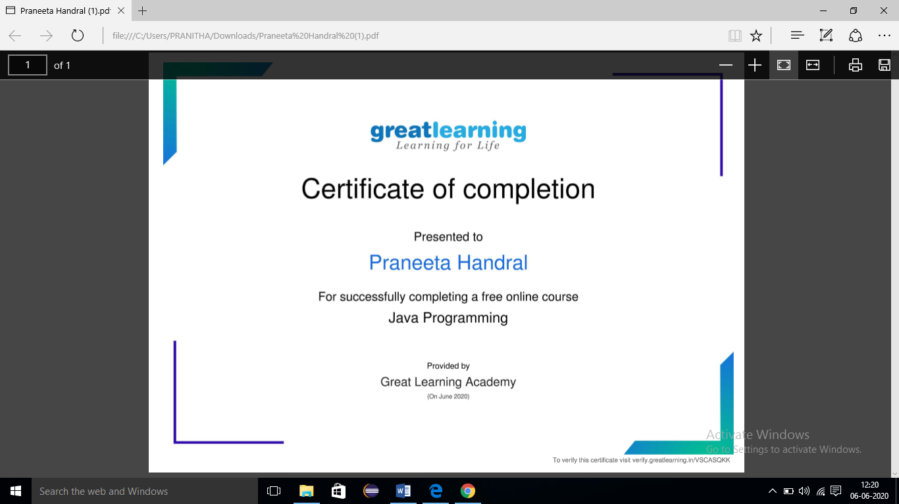

**Online Coding Summary: Today I received one program from Prof. Venkatesh CSE Dept. The program is mentioned above. to my GitHub repository and I’ve shared the snapshot below.**

